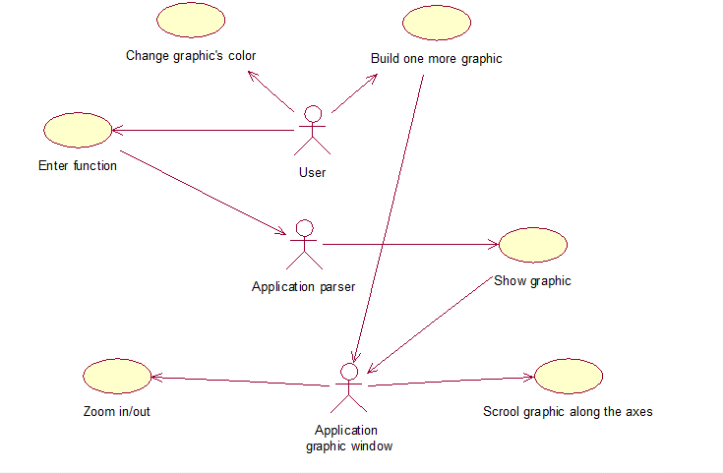

**Events flow for the use case “Change graphic’s color”**

Short description

This event called when user wants to change the color of the graphic.

Main events flow

1. User click on the special button

2. The list with available graphic's colors showed

3. User choose what he needs

4. If some graphic is showing right now, its color is changing

Alternative events flow

No alternative events.

Error events flow

No error events.

Post conditions

1. Graphic with new color shows on the widget.

**Events flow for the use case “Build one more graphic”**

Short description

This event called when user wants to superimpose the graphic on another one.

Main events flow

1. User choose the ability of showing another graphic

2. Another function parser area showed

Alternative events flow

1. User can delete one graphic, if this number more than 1

2. Another function parser area is closed

Error events flow

No user errors, cuz "add/remove graphic" actions accessibility checks by the application.

Post conditions

1. Another text field shows
2. Another graphic after parsing will show in the same coordinate plane.

**Events flow for the use case “Enter function”**

Short description

This event is available during application working.

Main events flow

1. The special text field is showing during the application working

2. User inputs function

3. Parser called after any changes in the text field

Alternative events flow

No alternative events.

Error events flow

1. Parser returned error value

2. Special text area highlighted with red.

Post conditions

1. Graphic’s builder calls.

**Events flow for the use case “Show graphic”**

Short description

This event called after successfully parse of the function.

Main events flow

1. If the function parsed correctly, it goes to this class

2. Graphic builds point by point in necessary scale

3. Graphic shows in the widget

Alternative events flow

1. Graphic builds over another

2. Coordinates of cusps highlighted in the widget.

Error events flow

1. During building graphic any errors occurred

2. Function parser called again

3. Widget highlight with red.

Post conditions

1. Function showing calls.

**Events flow for the use case “Zoom in/out”**

Short description

This event called if user wants to double tap zoom the graphic widget.

Main events flow

1. User double tap zoom in/out graphic widget

2. The graphic's scale is changing

Alternative events flow

No alternative events.

Error events flow

1. Function's range of values finished

2. Graphic building stopped.

Post conditions

No post conditions.

**Events flow for the use case “Scroll graphic along the axes”**

Short description

This event called if user wants to scroll the graphic widget.

Main events flow

1. User scroll graphic's widget

2. Widget shows further graphic's behavior during one of the axes

Alternative events flow

No alternative events.

Error events flow

1. Function's range of values finished

2. Graphic building stopped.

Post conditions

No post conditions.